Basic Treatment Guidelines for detoxification:

The following are general lifestyle recommendations that will establish a healthy routine as well as promote detoxification mainly through your digestive system, liver, kidneys, skin and lungs. There are two main goals alongside our additional recommendations:

- Establish a routine to promote a healthy lifestyle: It’s often the simplest interventions in life that can have the greatest impact on our health. The following are basic, foundational activities that can facilitate healthy elimination as well as maintaining a vital environment within our bodies.
- Enhance your body’s ability to detoxify in order to promote wellness: In this day and age, our bodies are bombarded with many different variables that can affect our health. We live in a dynamic and often toxic world. As life goes on, we build up a “burden” of toxins and stressors that can negatively impact our health. It is critical to encourage elimination of these toxins, metabolic byproducts and other stressors on a daily basis.
We produce urine through our kidneys, stool through our gastrointestinal tract, gas through our lungs and sweat via our skin; all of these organs are known as emunctories, or organs of elimination.
Achieving a healthy balance between our vital organs and stimulating elimination will enable a powerful additive alongside our other recommendations.
In addition, stimulating blood and lymph flow will propel the emunctories even more through exercise!

Primary Recommendations:
- Adequate sleep: Most adults need 7-9 hours a sleep in order to feel rested or renewed. Below is a great chart from the National Sleep Foundation on sleep recommendations by age. Try to go to bed and wake up at the same time everyday to help manage your natural circadian rhythm.
  - Sleep hygiene is also critical, as it is important to avoid electronics at least 1-3 hours before bedtime, as well as not eating large meals before bedtime or drinking alcohol/caffeine.
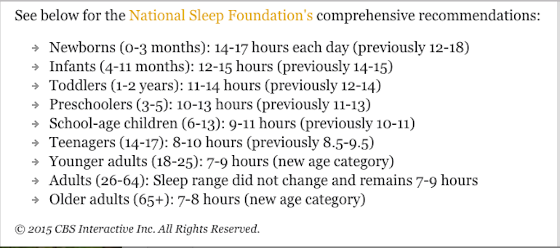
- Exercise/spend time outside: Everyone knows this, however it is important to understand that exercise helps improve circulation and remove wastes and stress from your body. It also enhances metabolism, which can play a large role in the way your body functions. 30 minutes 5x a week at a minimum is the amount needed to decrease cancer risk by half according the American Cancer Society, and to put you at lowest risk for dementia according to the Journal of Neurology.
  - Aim to exercise 5-7 days a week, at least 45 minutes each time.
  - Fresh air and sunshine are also important for obtaining vitamin D; get outside more often.
- Sweat: Research has shown that using an infrared sauna 3 times a week can drastically reduce cardiovascular events. It is also an important mechanism for your skin to detoxify and get rid of wastes. If you do not have access, regular sauna or making sure to get adequate exercise to induce sweating.
  - Aim for 3 times a week, for 20-30 minutes each time.
- Water: Aim for ½ your body weight in ounces (i.e. if you weigh 200lbs. you have to drink 100oz of water daily). Use glass or BPA-free water bottles to avoid phthalates from plastic. Water bathes our cells, and has the ability to carry wastes out of our body. In addition, if you drink coffee or alcohol, it is important to match that amount in extra water intake for the day.
- Deep breathing: Take some time everyday to consciously breathe deeply, using your abdomen. A good rule of thumb is 4-4-4-4 (4-square), inhale for 4 seconds, hold for 4 seconds, exhale for 4 seconds and hold for 4 seconds, and repeat. Aim for 50 conscious breathes a day, space them throughout the day. It may seem like a lot, but if you space them in sets of 10, you will get used to that routine.
- Diet: In general, for food hygiene, make sure you chew your food, avoid drinking fluids with food (will dilute digestive juices), and eat in a relaxed, non-stressful environment.
- Fun: When was the last time your doctor told you to laugh? Maybe in Patch Adams? We encourage you to have fun everyday, smile and have a positive outlook, and make sure you laugh daily!
Specific Home Recommendations:
Castor oil packs:These wonderful concoctions help stimulate the liver specifically and enhance detoxification. Ideally, aim for these 3 times a week, 30-45 minutes each time, typically when you are winding down at night. *Do not do this over an open wound or during menses. The following is the protocol:
- Fold a cloth flannel or old T-shirt 3 layers thick (the size of your abdomen), and saturate with room temperature castor oil
- Lie on your back with feet elevated (place pillow under knees) and place cloth over your liver area on the mid to right upper abdomen; place a plastic bag or saran wrap over the cloth, then place a hot water bottle on the top
- Cover entire abdomen with an old towel for insulation (caution that the oil does stain, so watch for leaks or lay on an old towel underneath your body)
- Leave pack on for 30-45 minutes
- When finished, remove the pack and wash the area with warm soap water (save the pack in a Ziploc bag for future use, until it is discolored)
Dry skin brushing: Using a natural fiber brush (or loofa), brush the surface of your skin starting at your extremities and working towards your heart. You should brush for approximately 1 minute before entering the shower. This will help move your lymph primarily; as well as open skin pores.
End your shower on cold: Contrast hydrotherapy is a powerful tool that can awaken your body and jump-start your day. End your shower with cool water (not freezing cold) for 30-60 seconds, especially on your kidney/adrenal gland area on the mid/lower back.

